Workloads

What are Workloads?

A workload is an application running on Kubernetes. Whether you’re workload is a single component or several that work together, workloads are the combination of resources that make it possible.

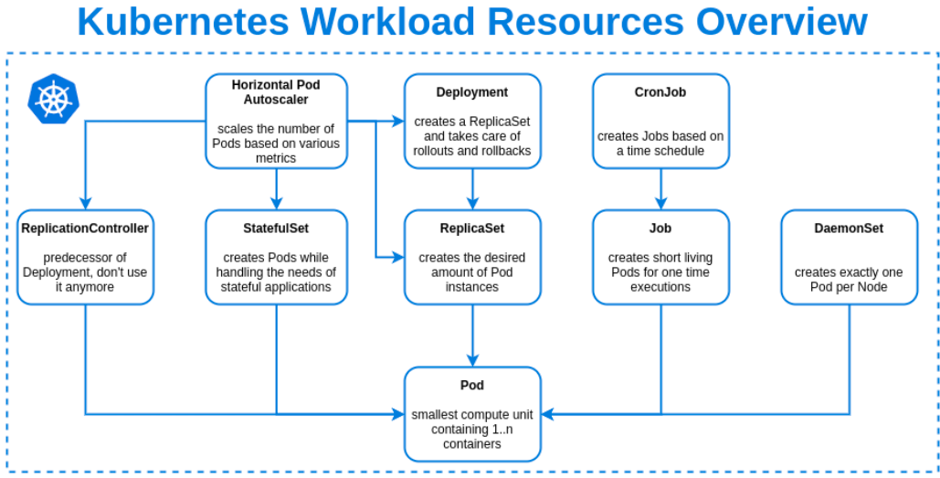

In Kubernetes a deployment is a resource object that provides declarative updates to applications. A deployment allows you to describe an application’s life cycle, such as which images to use for the app, the number of pods there should be, and the way in which they should be updated. The deployment is the describes the desired state of an object.

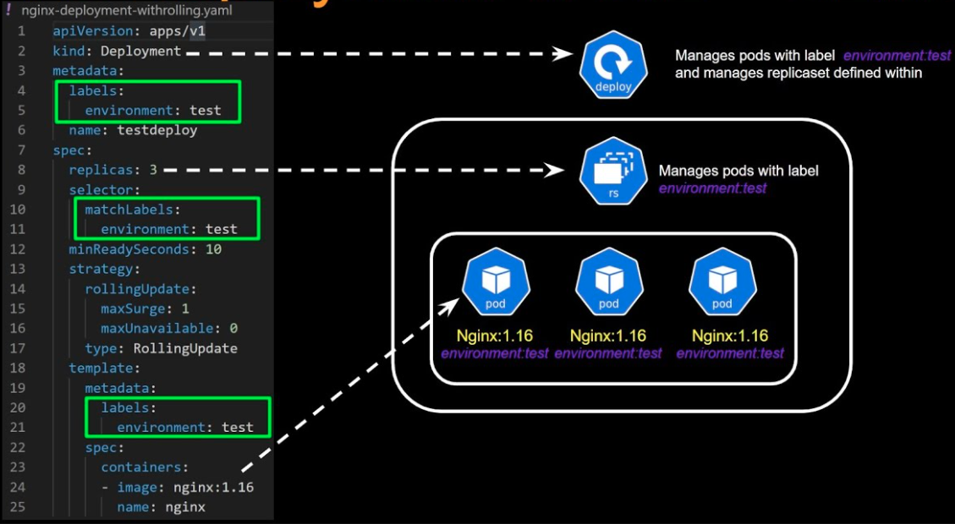
In this example we can read the above deployment using field selectors:
-A Deployment named ‘testdeploy’ is created, indicated by the .metadata.name field.
-The Deployment creates three replicated Pods, indicated by the .spec.replicas field.
-These fields create the deployment, which then defines the object running in a pod.

A Kubernetes object is a way to tell the Kubernetes system how you want your cluster’s workload to look. After an object has been created, the cluster works to ensure that the object exists, maintaining the desired state of your cluster.

You can also deploy rolling updates incrementally replace your resource's Pods with new ones, which are then scheduled on nodes with available resources. Rolling updates are designed to update your workloads without downtime. You can specify maxUnavailable and maxSurge to control the process.

Deployment ensures that only a certain number of Pods are down while they are being updated. By default, it ensures that at least 75% of the desired number of Pods are up (25% max unavailable).
Deployment also ensures that only a certain number of Pods are created above the desired number of Pods. By default, it ensures that at most 125% of the desired number of Pods are up (25% max surge).

Sometimes, you may want to rollback a Deployment; for example, when the Deployment is not stable, such as crash looping. By default, all of the Deployment's rollout history is kept in the system so that you can rollback anytime you want.

Hands on – Create, update, and rollback a deployment.

I. Create a deployment of 6 nginx instances running version 1.19.5, open to http traffic. The Deployment should also do a rolling update strategy, with a maxSurge of 50% and a maxUnavailable of 50%:

First, lets deploy our nginx pods and then verify that they are all running as expected.

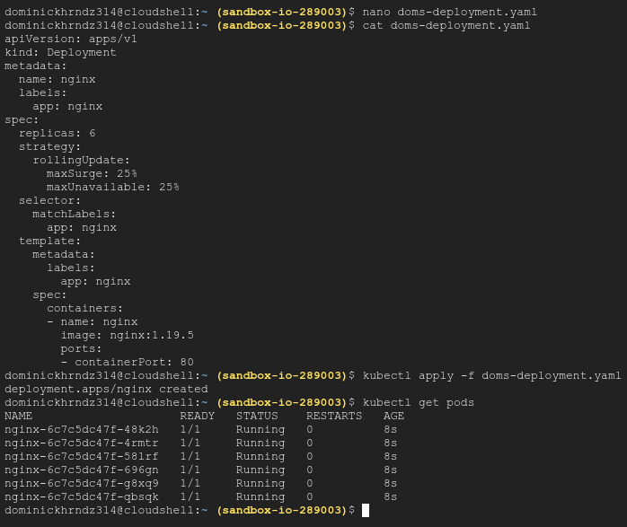

Describe the deployment and ensure you have 6 replicas, a StrategyType:RollingUpdate, and are running 25% on max surge/unavailable.

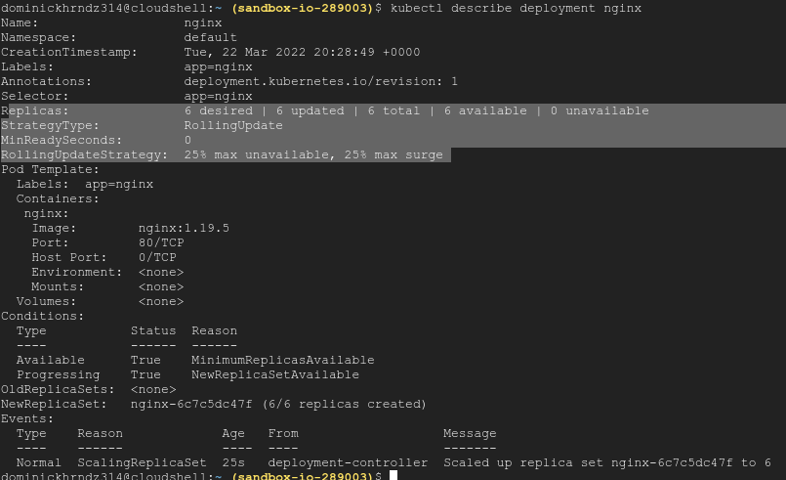
II. Update the nginx image to 1.19.6 and monitor the rollout:

To test our rolling update and roll back we need to upgrade our nginx version. Create a patch file that will update the version to 1.19.6 and will also change your maxSurge and maxUnavailable to 50%. Run kubectl patch deployment nginx –patch-file=yourname-patch.yaml to execute the update.

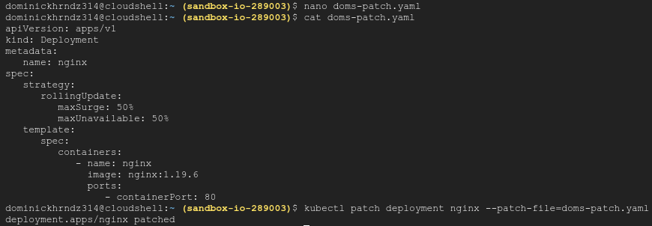

Verify that the RollingUpdate strategy has changed as well as the version of nginx.
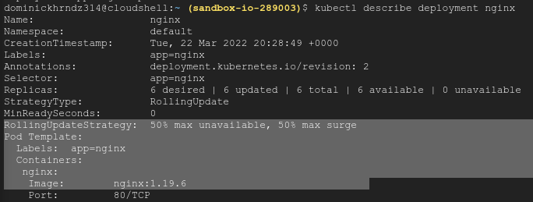

III. Rollback your changes:

Finally let’s rollback our changes to the previous version. Do a final kubectl describe deployment nginx to ensure you’re running 1.19.5 again.

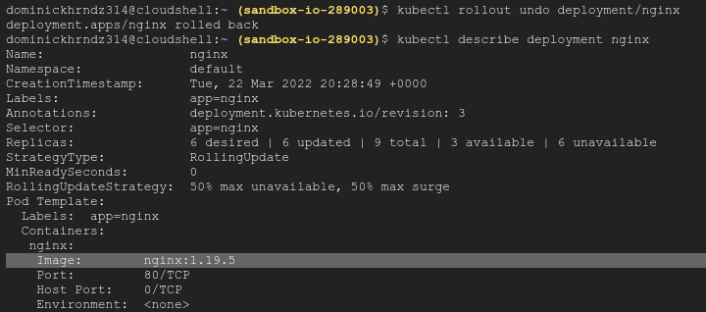
If you see the following, you have completed this training.

